Module 3: AdventureWorks Project - Milestone 1 - AWS Environment Build
Jadon Kosberg
First EC2 instance: Web Server A
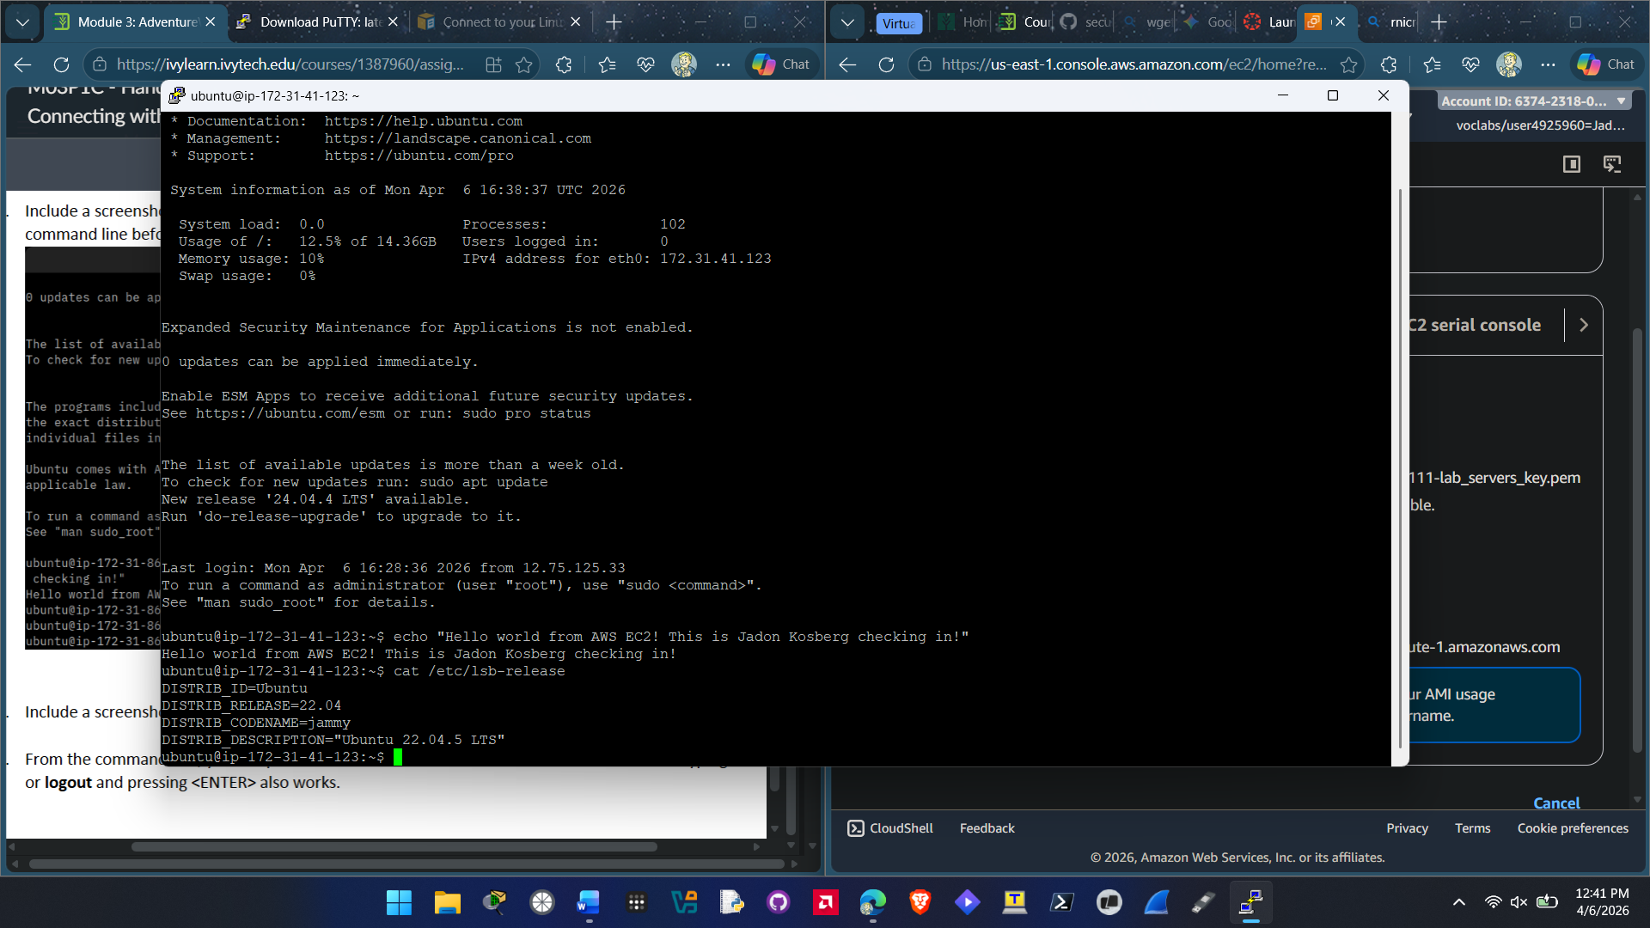
Second EC2 instance: Database Server B
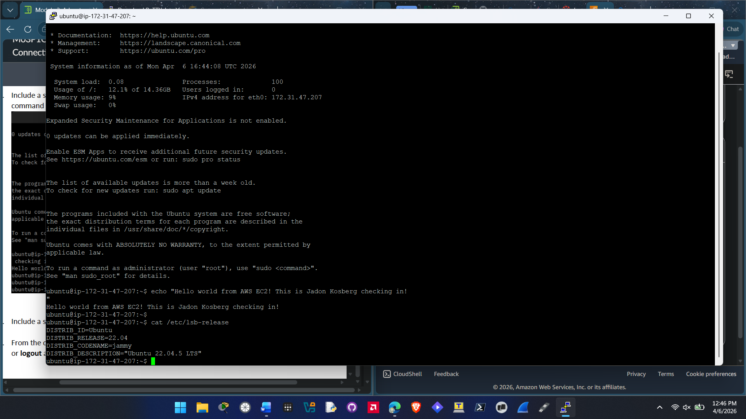
EC2 Instances Screenshot
